Computer Networks
2nd Year, 1st Semester
2022

Tutorial 1

- ABC Company just purchased three new routers to start their company network. Which items are needed to establish a terminal session between a PC and the router for the initial configuration?

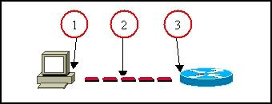

  - DB 9 Port
  - Console cable – Copper Cross-over cable (This is used to connect different types of devices with each other)
  - Console port (Router which is either 1841 or PT-router)

- State the methods to log to a router.
  - Console
  - Aux Port
  - TelNet – which is a protocol

- Explain the main modes found in the process of configuring the router.
  - User
  - Privilege
  - Configuration

- State the two ways to retrieve previously used commands.
  - Up and down arrow key navigation
  - show history

- How do you configure passwords for privilege mode?
Which password takes precedence?

  - enable password ABC / enable secret ABC, secret takes priority

- What are the functions of the RAM?
  - Store running or active configuration files

- Which keystrokes can be used to return to the privileged mode from the interface configuration mode?
  - Ctrl + z

- Which router component holds the configuration file when power is lost?
  - NVRAM

- How do you view the current configuration of the router?
  - show running-config (Mode – privilege mode)

- State the method of making a permanent copy of the configurations.
  - Copy running-config startup-config

